Nama : Arie Farchan Fyrzatullah

NIM : 103032330094

Kelas : IT-47-05

1. Dokter

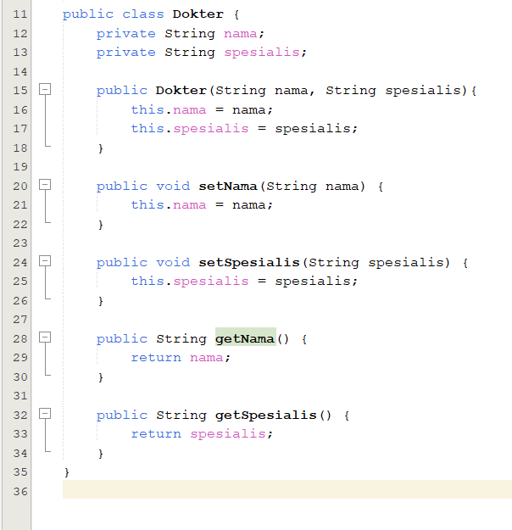

2. Pasien

3. Pemesanan

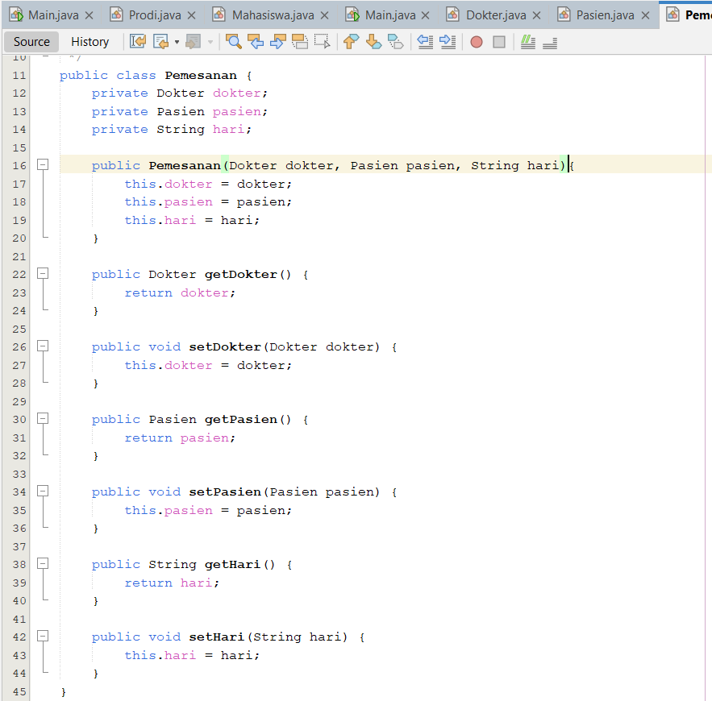

4. Main

Output:

